Source https://deluxeiceland.is/luxury-tours/ring-road-at-leisure/
__________________________________________________________

Self-Drive Iceland: Ring Road Discovery Tour
__________________________________________________________
★★★★★ 4.8/5 31 reviews

Add to wishlist ♡

__________________________________________________________

10 days / 9 nights | From €5,277 per person

🏕  Image | 🏕  Image | 🏕  Image | 🏕  Image | 🏕  Image | 🏕  Image

__________________________________________________________
About This Tour
The Ring Road at Leisure tour offers the perfect opportunity to explore Iceland at your own pace. This self-drive adventure takes you around Iceland’s famous Ring Road, giving you the freedom to stop at the most iconic and unique attractions along the way. From whale watching to glacier walking, enjoy the beauty of Iceland with the flexibility to explore at your own speed. This is the ideal tour for those seeking a more relaxed, personal experience while discovering Iceland’s natural wonders.
__________________________________________________________
What’s Waiting for You
- Duration: 10 days / 9 nights
- Group Size: Self-drive tour for 1-2 people or more
- Accommodation: Nine nights at Four/Three Star Hotels (Double Rooms with breakfast)
- Languages Available: English
- Private Guided Tour: Fully personalized self-drive experience
- Transportation: Luxury 4x4 Rental Vehicle with Wi-Fi, unlimited mileage, and CDW insurance
- Season: Available from 1 May to 31 Oct
__________________________________________________________

Check Dates & Availability

Select participants: (Age 99 and younger) - 1 +

Choose date:
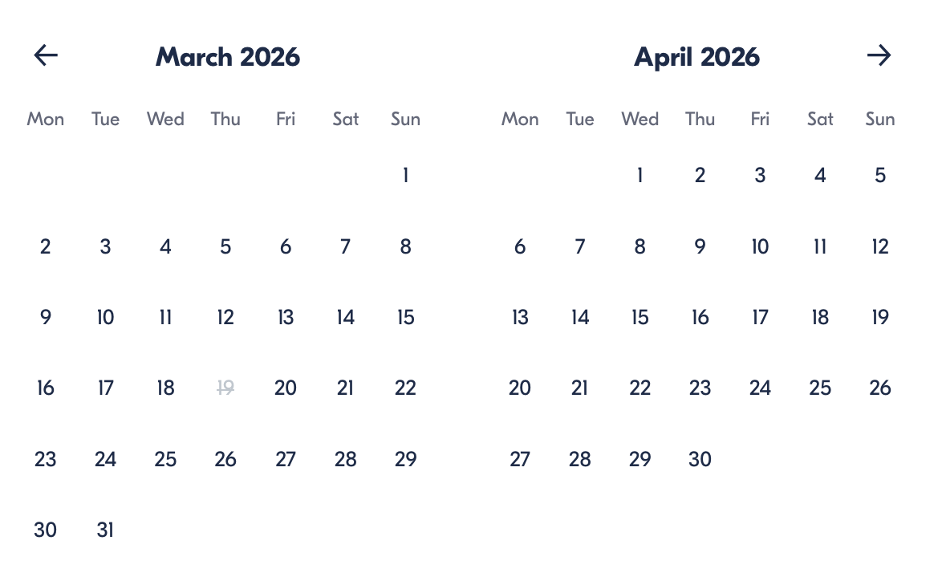

Check Availability

opens:

Participants: 2 March 16, 2026

Self-Drive Iceland: Ring Road Discovery Tour

- Duration: 10 days
- Offered in: English
- Starts at: 10:30 AM

Cancellation:

- More than two weeks prior to arrival: 40% Credit / 60% Refunded
- Less than two weeks prior to arrival: 50% Credit / 50% Refunded
- Less than 72 hours prior to arrival: No refund and no credit

Price breakdown: 2 Participants x €5,277

Total: €10,554

The total price includes all taxes and fees.

Add to cart Book now

__________________________________________________________
Tour Features
- Self-Drive Experience: Drive at your own pace along Iceland’s Ring Road
- Luxury 4x4 Rental Vehicle: Choose from top models like Mercedes-Benz GLE, Land Rover Defender, or Discovery
- Private Zodiac Boat Tour: Experience whale watching and seals
- Private Glacier Walking Tour: Hike on Iceland’s glaciers with a professional guide
- Relaxing Spa: Soak in the Blue Lagoon’s geothermal waters at the end of your journey
__________________________________________________________
Detailed Itinerary
- Day 1 – Arrival in Reykjavik
Arrive in Iceland at Keflavik Airport, where your private representative will greet you and take you to Reykjavik. Pick up your luxury rental car and go over your itinerary in detail. Spend the rest of the day exploring Reykjavik at your own pace, with plenty of museums, restaurants, and bars to choose from.
Accommodation:
Hotel Borg, Reykjavik (Included in price)
__________________________________________________________
- Day 2 – The Golden Circle
Drive the Golden Circle route, starting with a visit to Þingvellir National Park. Learn about the world’s first parliament and enjoy a light hike. Continue to the Geysir Geothermal Area and witness the explosive Strokkur geyser. End the day at Gullfoss Waterfall, one of Iceland’s most famous falls, before heading to your accommodation for the night.
Accommodation:
Hotel Rangá, South Iceland (Included in price)
__________________________________________________________
- Day 3 – The South Shore & Glacier Walk
Continue along the South Shore, stopping at Seljalandsfoss and Skógafoss waterfalls. Then, take a guided glacier walking tour on Sólheimajökull Glacier. The stunning glacier views will leave you in awe. Afterward, head east to your next hotel.
Accommodation:
Hotel Rangá, South Iceland (Included in price)
__________________________________________________________
- Day 4 – The Glacier Lagoon & Zodiac Boat Ride
Visit the spectacular Jökulsárlón Glacier Lagoon and enjoy a Zodiac boat tour among massive icebergs. Taste the 1,000-year-old ice and keep an eye out for seals. Experience the serenity of this natural wonder before heading to your accommodation.
Accommodation:
Fosshotel Glacier Lagoon, Southeast Iceland (Included in price)
__________________________________________________________
- Day 5 – The Eastfjords & Viking Village
Drive along the Eastfjords, stopping at the stunning Vestrahorn mountain and the Viking Village. Continue to Höfn, a charming fishing town surrounded by incredible views and seafood delicacies.
Accommodation:
Fosshotel Eastfjords, East Iceland (Included in price)
__________________________________________________________
- Day 6 – Lake Myvatn & Geothermal Baths
Explore the volcanic landscapes of Lake Myvatn, including the Dimmuborgir Lava Fields and the Skútustaðagígar Craters. Visit the Hverir Hot Springs before relaxing in the Mývatn Nature Baths, Iceland’s geothermal spa.
Accommodation:
Fosshotel Myvatn, North Iceland (Included in price)
__________________________________________________________
- Day 7 – Húsavík Whale Watching & Akureyri
Travel to Húsavík, the whale-watching capital of Iceland. Go on a whale watching tour and enjoy a cozy lunch in this quaint town. On the way to Akureyri, stop at Goðafoss Waterfall and explore the charming town of Siglufjörður.
Accommodation:
Siglo Hotel, North Iceland (Included in price)
__________________________________________________________
- Day 8 – Hofsos Pool & Stykkishólmur
Relax in the beautiful Hofsos Swimming Pool, with stunning views over the fjord. Continue your journey to Snæfellsnes Peninsula, and then to Stykkishólmur, known for its picturesque harbor and surrounding landscapes.
Accommodation:
Fosshotel Stykkishólmur, West Iceland (Included in price)
__________________________________________________________
- Day 9 – The Magical Snæfellsnes Peninsula
Explore the Snæfellsnes Peninsula, where you’ll visit the famous Kirkjufell Mountain and dramatic cliffs at Arnarstapi and Hellnar. Enjoy the natural beauty and geological wonders of this magical place.
Accommodation:
Fosshotel Stykkishólmur, West Iceland (Included in price)
__________________________________________________________
- Day 10 – Departure via Blue Lagoon
On your final day, relax and unwind at the Blue Lagoon, enjoying premium access to the geothermal spa. Afterward, return your rental car and head to Keflavik Airport for your departure.
__________________________________________________________
Included in Price
- Luxury 4x4 Rental Vehicle with Wi-Fi and unlimited mileage
- CDW Insurance and Map of Iceland
- Retreat Spa Entrance to Blue Lagoon
- Private Zodiac Boat Tour and Whale Watching
- Private Glacier Walking Tour
- Entrance to Mývatn Nature Baths
- Private arrival transfer & meeting with a Deluxe Iceland representative
- Nine nights at Four/Three Star Hotels (Double Rooms with breakfast)
- All taxes and fees – no hidden charges
__________________________________________________________
Not Included
- Meals (Lunches and dinners are not included)
- International Flights
__________________________________________________________

Cancellation Policy
For 5 or Fewer Participants:
- More than 2 weeks before arrival: 40% Credit / 60% Refund
- Less than 2 weeks before arrival: 50% Credit / 50% Refund
- Less than 72 hours before arrival: No refund or credit
For 6 or More Participants:
- More than 4 weeks before arrival: 40% Credit / 60% Refund
- Less than 4 weeks before arrival: 80% Credit / 20% Refund
- Less than 2 weeks before arrival: No refund or credit
Changes in the number of participants may increase the price per person. We recommend comprehensive travel insurance.
Weather-Related Cancellations:
If activities are canceled due to weather, they will be fully refunded. Itineraries may change based on conditions, with safety as the top priority.
Refund Processing:
Refunds are processed within 15 days after the tour ends.
__________________________________________________________
What Our Clients Are Saying

Overall rating  4.8/5  ★★★★★  Based on 31 reviews | Review summary  Guide 4.5/5  Transportation 4.6/5  Service 4.7/5  Organisation 4.5/5

Filter  - All traveller types  - Couples  - Group of friends  - Families  By star rating  - All star ratings  - 5 stars  - 4 stars  - 3 stars  - 2 stars  - 1 star | Search reviews (e.g., guide)  Sort by:  - Top picks  - Latest reviews  - Best ratings  - Lowest ratings
__________________________________________________________
★★★★★
Jacob – Hungary
An unforgettable experience! The self-drive tour was perfect. We loved exploring Iceland at our own pace while still visiting all the highlights. I highly recommend!

★★★★★
Silvester – Portugal
The best way to see Iceland! The itinerary was well-paced, and we had so much flexibility. The glacier walk and whale watching were unforgettable!

★★★★☆
Samantha – France
Une excellente expérience! La visite de l’île était magnifique et le voyage en voiture était agréable. J’aurais aimé un peu plus de temps à Reykjavík, mais c’était une aventure incroyable.

See more reviews
__________________________________________________________

Meta tags

Page - Self-Drive Iceland: Ring Road Discovery Tour

Title: Self-Drive Iceland: Ring Road Discovery Tour | Travellio Global

Description: Embark on a 10-day self-drive journey through Iceland’s famous Ring Road. Discover iconic landscapes, waterfalls, glaciers, and volcanic wonders at your own pace with a luxury rental vehicle and personalized itinerary.

H1 - Self-Drive Iceland: Ring Road Discovery Tour
__________________________________________________________

